

**Software Requirements Specification (SRS) Document**

## Railway Commodity Reservation System

### Version: 1.0

### **Guided Faculty: DIPANWITA GHOSH**

### Project Team:

|  |  |
| --- | --- |
| Priti Gupta | 221000120118 |
| John Hembrom | 221000120119 |
| Somnath Das | 221000120122 |
| Probhakar Thapa | 221000120137 |
| Suman Tewary | 221000120125 |
|  |  |

**Table of Contents**

1. Introduction
   * 1.1 Purpose
   * 1.2 Scope
   * 1.3 Definitions, Acronyms, and Abbreviations
   * 1.4 References
   * 1.5 Overview of the Document
2. General Description
   * 2.1 Product Perspective
   * 2.2 Product Functions
   * 2.3 User Characteristics
   * 2.4 General Constraints
   * 2.5 Assumptions and Dependencies
3. Specific Requirements
   * 3.1 External Interface Requirements
     + 3.1.1 User Interfaces
     + 3.1.2 Hardware Interfaces
     + 3.1.3 Software Interfaces
     + 3.1.4 Communication Interfaces
   * 3.2 Functional Requirements
     + 3.2.1 User Authentication and Registration
     + 3.2.2 Train and Schedule Management
     + 3.2.3 Cargo Management
     + 3.2.4 Booking Management
   * 3.3 Performance Requirements
   * 3.4 Design Constraints
   * 3.5 Software System Attributes
   * 3.6 Entity-Relationship (ER) Diagram
4. Other Nonfunctional Requirements
   * 4.1 Usability
   * 4.2 Scalability
   * 4.3 Compatibility
5. Appendices
   * 5.1 Glossary
6. Revision History

# Software Requirements Specification (SRS) Document

## 1. Introduction

The purpose of this document is to provide a comprehensive description of the requirements for the development of the Train Booking System. The system aims to facilitate the booking of train tickets, management of trains and schedules, handling of cargo, and booking management at stations. This document serves as a guide for developers, testers, and stakeholders involved in the project.

### 1.1 Purpose

The Train Booking System aims to provide a user-friendly platform for users to book train tickets efficiently and for administrators to manage trains and cargo effectively. The system intends to streamline the booking process and ensure a seamless experience for both users and administrators.

### 1.2 Scope

The Train Booking System will include modules for user authentication, train and schedule management, cargo handling, and booking management. It will cater to the needs of both regular users and administrators, offering features for booking, managing, and tracking train journeys.

### 1.3 Definitions, Acronyms, and Abbreviations

* **User**: A person who accesses the system to book trains.
* **Admin**: A privileged user responsible for managing trains and cargo.
* **Train**: A mode of transportation available for booking.
* **Cargo**: Goods or commodities transported via trains.
* **Booking**: The process of reserving a train ticket.
* **SRS**: Software Requirements Specification.

### 1.4 References

N/A

### 1.5 Overview of the Document

This document comprises sections describing the general system description, detailed requirements, non-functional requirements, and appendices containing additional information and glossary.

## 2. General Description

### 2.1 Product Perspective

The Train Booking System is a standalone web application that interacts with users through a user-friendly interface. It interfaces with a backend database management system (DBMS) to store and retrieve information related to users, trains, schedules, cargo, and bookings.

### 2.2 Product Functions

The system provides the following primary functions:

* User authentication and registration
* Train and schedule management
* Cargo handling and management
* Booking management and tracking

### 2.3 User Characteristics

* **Regular Users**: Individuals who book trains for personal or business travel.
* **Administrators**: Privileged users responsible for managing trains, schedules, cargo, and bookings.

### 2.4 General Constraints

* The system must be accessible over the internet through standard web browsers.
* Data security and privacy must be ensured in accordance with applicable regulations.
* The system should be scalable to accommodate a growing number of users and data.

### 2.5 Assumptions and Dependencies

* The system assumes a stable internet connection for users to access it.
* The system relies on a backend DBMS for data storage, retrieval, and management.

## 3. Specific Requirements

### 3.1 External Interface Requirements

#### 3.1.1 User Interfaces

The system will feature intuitive web-based interfaces for both regular users and administrators. Users will interact with the system through forms, buttons, and menus for various functionalities.

#### 3.1.2 Hardware Interfaces

The system will be accessible on standard desktop and mobile devices with web browsing capabilities.

#### 3.1.3 Software Interfaces

The system will interface with a backend DBMS, likely MySQL, for data storage and retrieval.

#### 3.1.4 Communication Interfaces

The system will communicate with users over HTTP/HTTPS protocols for secure data transmission.

### 3.2 Functional Requirements

#### 3.2.1 User Authentication and Registration

* The system shall allow users to register with unique usernames, email addresses, and passwords.
* The system shall authenticate users based on their credentials (username/email and password).

#### 3.2.2 Train and Schedule Management

* Administrators shall be able to add, edit, and delete train information, including TrainID, TrainName, Capacity, and Cost.
* Administrators shall create and manage train schedules, specifying departure and arrival times for each train.

#### 3.2.3 Cargo Management

* Administrators shall be able to add, edit, and delete cargo information, including CargoID, CommodityID, TrainID, Weight, and Status.

#### 3.2.4 Booking Management

* Users shall be able to search for available trains based on destination and date.
* Users shall book trains by selecting available cargo and specifying the destination station and date.
* The system shall calculate the cost of booking based on cargo weight and other factors.

### 3.3 Performance Requirements

* The system shall respond to user actions within 2 seconds under normal load conditions.
* The system shall handle concurrent user requests without significant performance degradation.

### 3.4 Design Constraints

* The system shall be developed using HTML, CSS, JavaScript for the frontend, and Django for the backend.
* The system shall use MySQL as the backend database.

### 3.5 Software System Attributes

* **Reliability**: The system shall be available 99.9% of the time, excluding scheduled maintenance windows.
* **Availability**: The system shall have scheduled maintenance windows for updates and patches.
* **Security**: The system shall encrypt user passwords and sensitive data during transmission using industry-standard encryption algorithms.

3.6 Entity-Relationship (ER) Diagram

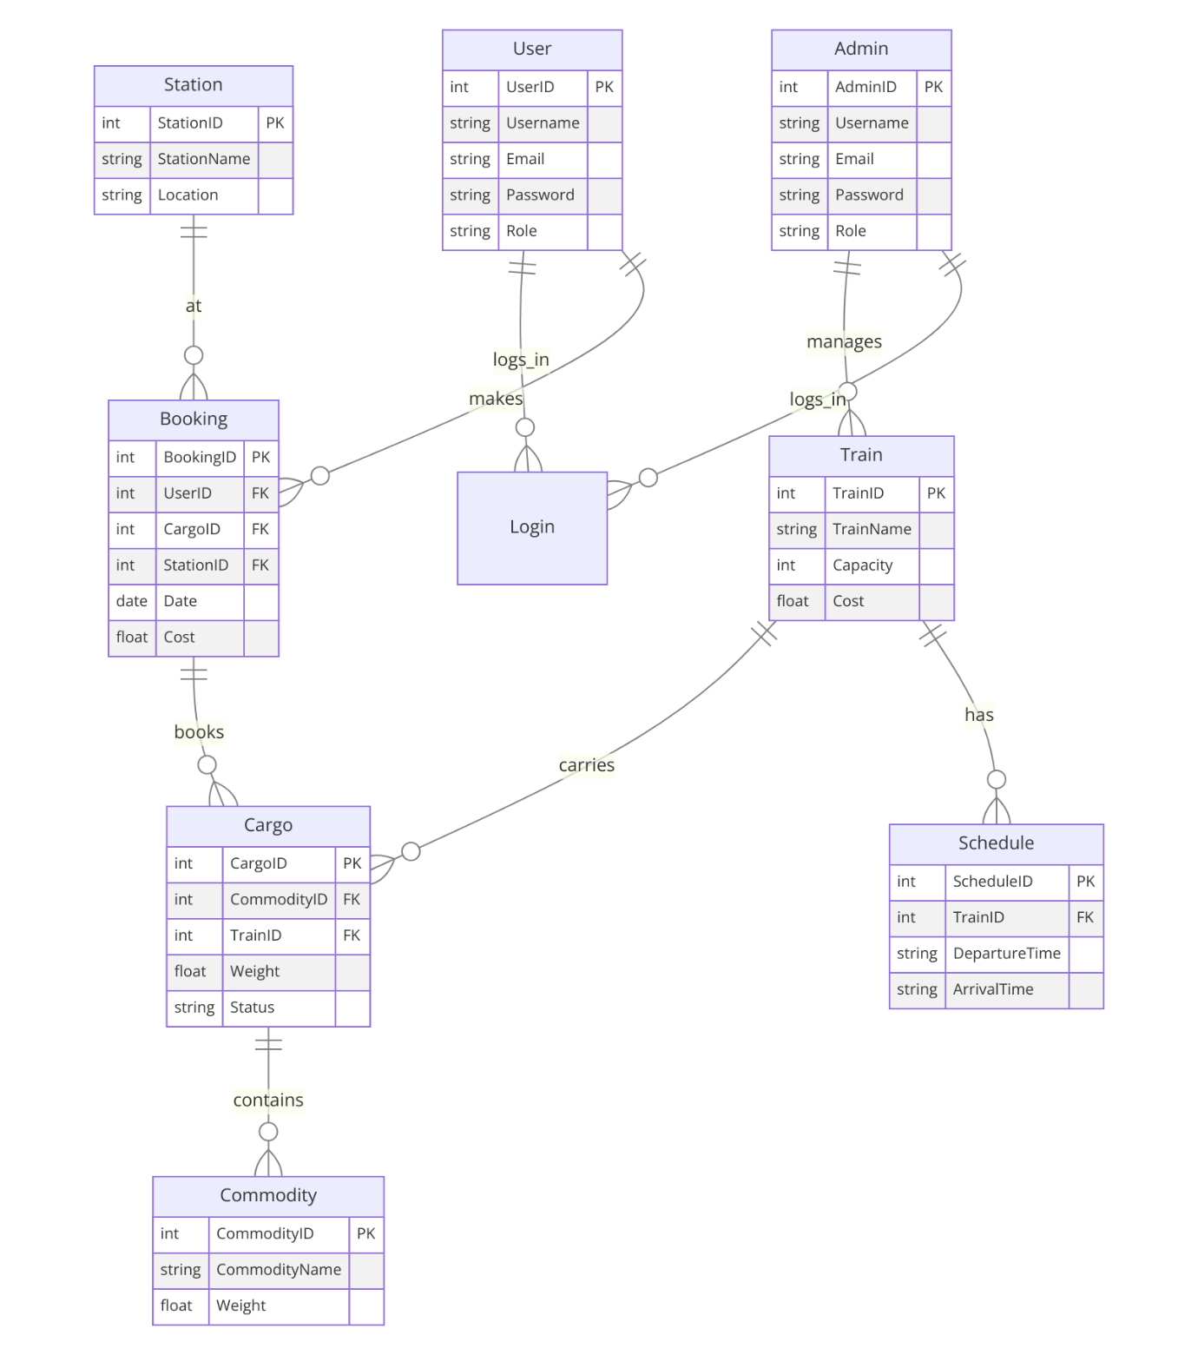

## 4. Other Nonfunctional Requirements

### 4.1 Usability

* The user interface shall be intuitive, visually appealing, and easy to navigate.
* The system shall provide informative error messages for user input validation.

### 4.2 Scalability

* The system shall be scalable to accommodate up to 10,000 concurrent users without performance degradation.

### 4.3 Compatibility

* The system shall be compatible with modern web browsers, including Chrome, Firefox, Safari, and Edge.

## 5. Appendices

### 5.1 Glossary

* **User**: A person who accesses the system to book trains.
* **Admin**: A privileged user responsible for managing trains and cargo.
* **Train**: A mode of transportation available for booking.
* **Cargo**: Goods or commodities transported via trains.
* **Booking**: The process of reserving a train ticket.

## 6. Revision History

* Version 1.0: Initial Release